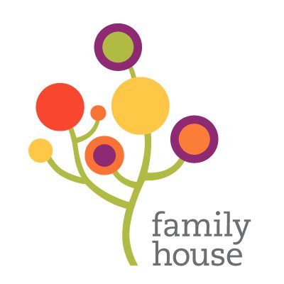

2022 Family House
Annual Report

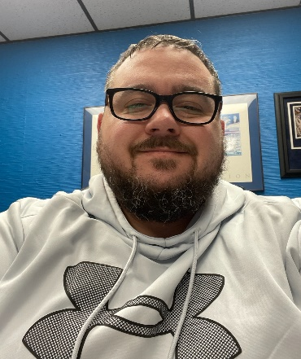
President of the Board of Directors’ Outgoing Message
2022 has been a year a mixed feeling. I have served as President of the Board for well over a decade and thinking back at my time and all the families especially the children we have served has made me proud. I attended our Fall Festival Fundraiser and to see two separate artists who were served by Family House at two very different times in my administration, giving back gave me such pride. I have seen much change in my time but what I am most proud of is that our mission has remained the same! We continue to give a hand up not a hand out. We continue to plan and set lofty goals for the future and I am proud that the Board has found new strong leadership in Chantel Cargill as the new President to take my place.
Chantell and her administration will continue the hard work that has been put forth and help us move forward with our strategic plan. My love for this organization cannot be said in words but I will continue to work with and support the work being done because the job isn’t done. Families continue to need the love and support provided by Family House. Since my time on the board we have served 5612 people, 3128 were children, 1471 were under the age of 5 which is the most devastating fact that I have to report. There are many children whose first address is that of Family House including a good number this year with 78 children under the age of 5 this year alone. A quote I read is “Time Flies but the good news is you’re the pilot” and I think everyone involved with Family House helped pilot the ship from rocky times to the best organization. Like I said there is still a lot of work to do but with the great leadership inside the organization and a strong board nothing is impossible for Family House.
2020-2022 Board President, Dino Peluso II
This Photo by Unknown Author is licensed under CC BY

2023-2024 President of the Board of Directors’ Incoming Message
It is a great honor to serve as the President of the Board of Directors for Family House Homeless Shelter. In reflecting on the last two years of my time on the board, I am filled with immense pride and regard for the work and dedication of the board which has pushed us to new heights, and will assist us in the future workings of the goals set before us.
In 2021, we began the journey to achieve the goals detailed in our strategic plan. Our board of directors were intentional about a few things:
- Reigniting our current board members and engaging new board members,
- Name recognition within our community
- Redefining our mission
- Increasing and improving the financial standing of the organization

Throughout 2022, we continued to set lofty goals to enhance our footprint within the community, the capacity to further serve our community, and the ways in which we can expand our reach to provide additional services to successfully move families from homelessness to self-sufficiency. With the exceptional leadership of our Executive Director and staff, we maintained quality programming while working through challenging times. It is through the support of our leadership, valued volunteers, supporters, as well as exemplary board leadership that Family House continues to evolve and consequently, enhance our capability to advance our strategic vision and goals.
Looking ahead, we continue to focus on a collaborative approach amongst our board and external partners, which continues to be essential to our overall success. Building and growing our collective experience and expertise internally, are the tools we know are needed and believe will directly impact Family House in ways we can only imagine. We continue to set our eyes forward and remain intentional about our end goals, and the ways in which we take each step. I’m excited that this year will bring more continued opportunities to advance.
Chantell Cargile, President Family House Board of Directors
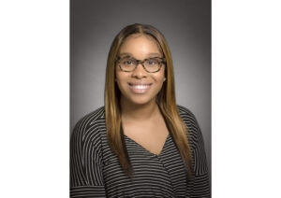

Operations & Building Services
There has been a great deal of instability in the kitchen and as a result, the Operations Director has spent several months, temporarily doing the work required to ensure clients eat each day. Family House was gifted a new commercial stove in July from The Toledo Metropolitan Women’s Club. The stove has been put to great use by the groups of volunteers who cook and serve during the weekends. Cedar Creek Church also supports Family House by providing dinner every Wednesday evening. We are very fortunate the community continues to support Family House by providing meals and volunteers during the Holiday Season. Connecting Kids supplies breakfast, lunch and dinner for all children ages one thru eighteen.
Our Clothing Donation room has been organized and we continue to receive clothing donations the first three business days of each month. The Aftercare room has been organized and continues to be supplied by donations from the community. Families who leave Family House and transition to permanent homes are supplied items such as toasters, microwaves, dishes and lamps, all of which has been donated by the community. We have received many donations of clothes, books and household items that have helped many of our families we serve.
Over the course of the past several months, a great number of repairs needed to be addressed and systems required inspection and cleaning. All of the needed repairs have been made and all systems have been inspected and cleared. Additionally, vehicles owned and operated by Family House staff have been inspected and necessary repairs have been completed. All repairs and inspections have been done by certified technicians and mechanics. The Building Services focus for the coming year is to keep the building safe and clean.

Volunteer Development
Family House cannot/could not function without the support of volunteers! Over the course of several years, particularly during the COVID-19 pandemic, there was a marked decrease in the number of volunteers. However, within the past twelve (12) months, we have noticed a resurgence of volunteers. Our goal is to surpass pre-pandemic numbers and to increase the number and frequency by which individuals volunteer.
The graphic below details the volunteers and the number of hours contributed over the past three years as well as the cost saved by Family House when individuals donate their time and talents.

 | 2019 | 2020 | 2021
Volunteers | 119 | 24 | 233
Hours | 2601 | 650.25 | 2870.5
Cost Savings | $28,611.00 | $7,152.75 | $33,019.00

2022 Financial Overview
Family House could not have been successful carrying out our mission without the generous support of private donors, in-kind donations, grants and fundraising revenue. With the continuous support of the community, Family House was able to provide families facing homelessness with a safe place to live and the necessary tools to become self-sufficient yet another fiscal 2021-2022 year. Family House received Covid-19 funds to help bridge the barrier gap for families in need. With the help of our community, Family House will continue to assist homeless families facing adversity.

This Photo by Unknown Author is licensed under CC BY-SA
As we continue moving through 2023, we wanted to share the organizational goals for the year.
The goals include:
- Increasing awareness regarding the awesome work being done at Family House.
- Increasing the number of volunteers and volunteer opportunities for community members.
- Diversifying and increasing revenue streams
- Developing a definitive plan for building renovation and/or move.

The above listed goals along with expanding client programming and services will be the touchstone of how this organization will move forward.

2022 Board of Directors
Dino Peluso II- President
Pastor Willi Perryman, PhD-Vice President
Mary Lynne Mousoulias, CPA-Treasurer
Adam Latham-Secretary
Heather Baker
Chantell Cargile
Patrick Donnelly
Anita Foreman
Pastor Perry Harris III
Tami Harris*
Greg Moore
Keith Nelson*
Yuri Osterhout
Frank Pertz, Esq*

Family House
Administrative Team
Tonia R. Pace, PhD, LSW
Executive Director

DeShanna Alexander
Associate Director

Gwyn Hager
Operations Director

Donna Jordan
Program Director

Clinton Chambers
Building Services

Mandy Phillips
Development/Volunteer Coordinator

